 | SUNDAY | MONDAY | TUESDAY | WEDNESDAY | THURSDAY | FRIDAY | SATURDAY
5:15am

6:00am |  | Total Body  Challenge |  | Hard Core  Cycle  (upstairs) | YOGA | Hard Core  Cycle  (upstairs)
8:00am |  |  |  |  |  | (8:30)  Yoga | Cycle  (upstairs)
9:00am |  | RIP | 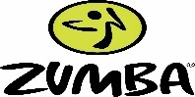 | Total Body  Challenge | BOX/ABS | (9:30)  Chisel | 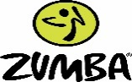
10:15am |  | Move & Groove | (10:00) Yoga | Move & Groove | Line dancing  (beginning) |  | 10:00  Saturday  Mix-up
11:15am |  |  | Line dancing  (Intermediate) |  | 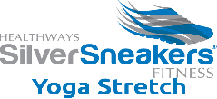
4:15pm |  | RIP |  | Yoga  (upstairs)  Barre (group ex) |  | Chisel  Or  Transform
5:15pm |  |  | Yoga  (Upstairs) |  | Yoga  (Upstairs)
5:30pm |  | 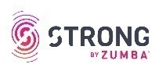 | WAR | 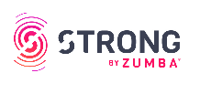 | RIP
6:30pm |  | Box/Strength | **Cycle**  c |  | **Cycle**
Yoga: Relax, strengthen & soothe the body & mind, while focusing on elongation, alignment, flexibility and breathing.
Barre Class: A dance inspired workout designed to enhance flexibility & balance while gaining strength & toning in the core, legs, glutes & arms.
Box: Prepare to sweat in this boot camp style boxing glass that rotates through intervals of punching Heavy Bags, kicks, drills & more. Gloves & mitts provided
Indoor Cycling: A fun, energetic, athletic cycling class. Ride through sprints, climbs, & recovery for a high calorie burning workout.
Chisel: A strength training class is designed to increase lean muscle tissue & metabolism. Blast the fat & define muscles. Weight equipment will be used.
Hard Core Cycle: This class will kick your ride up a notch by incorporating weight circuits off the bike maximizing calorie burn.
Line Dancing: A fun, choreographed dance class with a repeated sequence of steps. Intermediate & beginning levels classes available.
Move & Groove & Country Sizzle: Enjoy dancing to great music while improving cardiovascular health. These classes will be taught at a lower intensity level than Zumba Fitness
RIP-A Total body, 60 min choreographed Barbell/Weight Training Class. Strengthen, Tone & Define in record time.
Silver Sneaker’s Classic: Have fun while performing a variety of exercises designed to increase muscular strength & range motion. A chair is
available for seated or standing support. Hand weights, tubing and a ball is used. This class is a good start for members new to exercise.
SilverSneaker’s Stretch: Practice relaxing while increasing flexibility and range of motion. Chair & standing poses only are practiced in this class.
Strong by Zumba: A high intensity interval class (HIIT). You will be pushed past your perceived limits to reach your fitness goals
Total Body Challenge: Burn fat & tone up with this blend of cardio & strength training class using a variety of equipment.
Transform- A choreographed-hour long class blending yoga/pilates & sport exercises. .
War- An exhilarating total body workout where mixed martial arts (MMA) meets chart topping music. Become Armed & Dangerous!
Zumba Fitness: Exciting Latin moves and rhythms are combined with hip hop & international music to create a calorie torching, high energy dance party!

